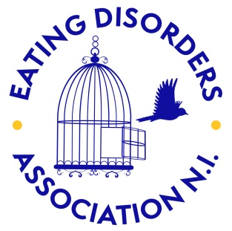

Please complete and return to*:*

*Eating Disorders Association NI*

*Bryson House*

*28 Bedford Street*

*Belfast*

*BT2 7FE*

*T: 02890235959*

*E: info@eatingdisordersni.co.uk*

**Workshop Booking Form**

Contact Name:

School/ Group Name:

Address:

Contact Number:

Contact Email:

I would like to book:

Student Workshop [ ]

Teacher Training [ ]

Other (*please give details*) [ ]

Date requested:

Number of sessions:

Estimated number of attendees:

Age of attendees:

14 and under [ ]

15-17 [ ]

18+ [ ]

Time Available per session:

Please note any additional requirements or requests: