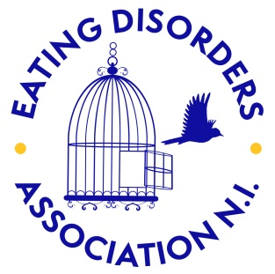
Please complete and return to:
Eating Disorders Association NI
Merrion Business Cnetre
58 Howard Street
Belfast
BT1 6PJ
T: 02890235959
E: info@eatingdisordersni.co.uk

Workshop Booking Form

Contact Name:

School/ Group Name:

Address:

Contact Number:
Contact Email:

I would like to book:
Student Workshop [ ]
Teacher Training [ ]
Other (please give details) [ ]

Date requested:

Number of sessions:

Estimated number of attendees:

Age of attendees:
14 and under [ ]
15-17 [ ]
18+ [ ]

Time Available per session:

Please note any additional requirements or requests:

